Forex Strategy.

Indicators.
- Martin meter indicator all three bars should be Red for a sell.
- 50 SMA. Top Green, bottom Red

Rules:
1.On a 1 hour chart, wait for the trend line to break the 50 SMA.
1- If its above the moving average you buy; if its bellow you sell

Entry.
- Enter on the Breakout or Retest (AND STICK TO IT!)
- 1:1 Ratio of 30 Pips more or less

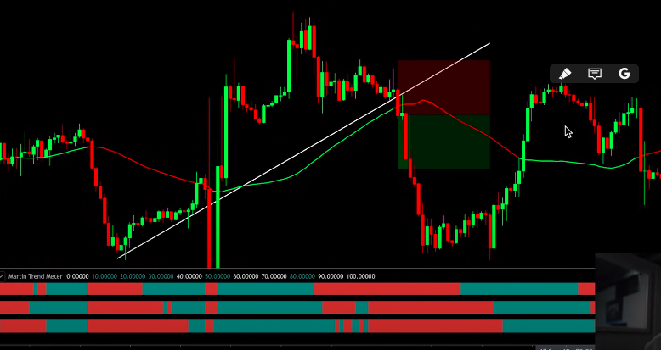
NOTE: when the market is underneath the 50 SMA we're looking for sale opportunities

